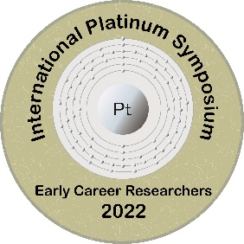
INTERNATIONAL PLATINUM SYMPOSIUM
EARLY CAREER RESEARCHERS
VIRTUAL CONFERENCE
MAY 2022

Abstract template

TITLE HERE FONT SIZE 12 CENTER ALIGNMENT
First Author Name (Name Surname)^{1*}, Second Author Name (Name Surname)²
¹ affiliation
² affiliation
*Corresponding Author E-mail

Text Here. Use Arial 10 throughout and italics only for non-English words (e.g.,. Durchbewegung texture). Justified text and double-space the entire submission. Text should have 400 words maximum. You can include up to 1 figure at the end of the text, figure captions not included in total words.
Abstracts must be submitted to PlatinumSymposium2022@gmail.com, please include in the subject “Abstract Surname Name”. Save your word.doc file as follows: PtSymp22_SurnameName. Call for abstracts opens Nov 1^{st,} 2021. Abstract submission deadline: March 1st, 2022

